
Department of Computer Engineering
Introduction to Embedded Systems (IES)
FINAL PROJECT:
IoT-based Smart Security and Automation Node

Submitted By | Hoor Aman
Registration No. | B24F0225CE039
Submitted To | Engr. Rafiullah
Department | BS Computer Engineering
Project | Final IoT-based Smart Security system
Subject | Introduction to Embedded Systems (IES)

1. Project Overview:
This project is an IoT-based Smart Security and Automation system built using the ESP32 microcontroller. It integrates multiple access methods including a keypad, Bluetooth, and WiFi web dashboard to control a solenoid door lock. The system provides real-time status updates through an LCD display and LEDs, along with security features like failed attempt tracking, delay-based lockouts, and permanent blocking for unauthorized access. It also supports remote monitoring and control, making the system secure, flexible, and suitable for modern smart security applications.

2.Abstract:
This report presents the design and implementation of an Internet of Things (IoT)-based Smart Security and Automation Node using the ESP32 microcontroller platform. The system offers multi-channel access control via physical input (4x4 matrix keypad), short-range wireless communication (Classic Bluetooth Serial), and wide-area wireless network control (WiFi-hosted responsive Web Dashboard). Real-time feedback is provided through a 16x2 Liquid Crystal Display (LCD) with I2C interfacing and status LEDs. Security features include dynamic rate-limiting cooldown periods for unauthorized access attempts, system lockouts, and persistent localized event logging with Network Time Protocol (NTP) synchronization. The electro-mechanical actuator (Solenoid Lock) is isolated and controlled through a 5V SPDT Relay module driven by an external 12V DC power source. Testing validated flawless remote operations, responsive local interfaces, and reliable safety implementations under simulated threat scenarios.

3. Introduction & Objectives:
In modern computing, physical security integration with networked nodes is a primary design pattern. Traditional mechanical locking mechanisms lack real-time audit logs, remote accessibility, and adaptive access-denial parameters. This project utilizes the dual-core processing capabilities and built-in transceiver hardware of the ESP32 to bridge this gap.

Key Objectives:
- To design and implement a smart, multi-modal access control node capable of local keypad decoding and wireless remote processing.
- To interface hardware elements such as matrix keypads, I2C character displays, and status-indicating LEDs to the micro-controller unit (MCU).
- To deploy a localized, lightweight web server on the ESP32 to provide an interactive dashboard UI for remote locking, unlocking, system status viewing, and event history retrieval.
- To implement robust security features, including progressive delay lockouts (10s, 20s, 30s) and an auto-blocking state after repeated failures.

4. Component Specifications & Requirements:
Component Name | Technical Specifications Used | Purpose in Circuit
ESP32 Development Board | NodeMCU ESP-WROOM-32, 30-pin layout, built-in WiFi & Bluetooth | Core Processor / IoT Gateway
LCD 16x2 Display with I2C | 16 characters x 2 rows, PCF8574 I2C adapter backpack (address 0x27) | Visual Feedback and Timer display
Matrix Keypad 4x4 | 16-key membrane layout (Rows/Cols mapped to GPIOs) | Local Password Character Entry
5V Relay Module | Single Pole Double Throw (SPDT), optoisolated input trigger | Switching high current load (12V) using low power 3.3V GPIO
Solenoid Door Lock | 12V DC operating voltage, pull-in current ~1A | Mechanical physical locking/unlocking actuator
Light Emitting Diodes (LEDs) | Red LED (GPIO 19), Green LED (GPIO 18) | Status Indications (Red = Locked, Green = Unlocked)
Current Limiting Resistors | 220 Ω resistors (for both LEDs) | Prevents overcurrent damage to ESP32 GPIO pins
External Power Source | 12V DC Battery / Power adapter | Drives the 12V Solenoid lock coil

5. Hardware Wiring & Pin Mapping:
The system's structural connections are detailed below. All digital input/output mapping has been engineered to avoid critical ESP32 strapping pins (such as GPIO 0, 2, 5, 12, and 15) during booting sequences to ensure startup stability.

Connection Matrix Table:
Source Device Component | Pin Name / Connection | ESP32 GPIO Pin | Description / Notes
I2C LCD Module | SDA | GPIO 21 | Inter-Integrated Circuit (I2C) Data line
 | SCL | GPIO 22 | Inter-Integrated Circuit (I2C) Clock line
LED Indicators | GREEN LED Anode | GPIO 18 | Output through 220 Ω resistor to GND
 | RED LED Anode | GPIO 19 | Output through 220 Ω resistor to GND
Relay Module | IN (Control Input) | GPIO 4 | Logic LOW activates solenoid (unlocks)
4x4 Membrane Keypad | Row 1 | GPIO 25 | Matrix Keypad Row 1 Output Control
 | Row 2 | GPIO 26 | Matrix Keypad Row 2 Output Control
 | Row 3 | GPIO 32 | Matrix Keypad Row 3 Output Control
 | Row 4 | GPIO 33 | Matrix Keypad Row 4 Output Control
 | Column 1 | GPIO 13 | Matrix Keypad Column 1 Input Sense
 | Column 2 | GPIO 12 | Matrix Keypad Column 2 Input Sense
 | Column 3 | GPIO 14 | Matrix Keypad Column 3 Input Sense
 | Column 4 | GPIO 27 | Matrix Keypad Column 4 Input Sense

6. Software Architecture & Implementation:
The program is built using a modular Object-Oriented design in C++. It leverages several open-source libraries: WiFi.h, WebServer.h, BluetoothSerial.h, LiquidCrystal_I2C.h, and Keypad.h.

System Core Logic & Functional States:
- Startup Check: During initialization, a system verification routine flashes both LEDs for 300 ms to confirm operational hardware before locking the door by default.
- Access State Machine:
  - LOCKED: Red LED remains active, Green LED remains inactive. The LCD continuously prompts the user to enter a passcode.
  - UNLOCKED: Upon validating a key, the Green LED activates, the Red LED shuts off, and the relay switches LOW to engage the solenoid. After 2 seconds, the system auto-locks.
- Progressive Penalties & Cooldown Mode:
  - Incorrect input triggers a 3x blink pattern on the Red LED.
  - 1st Failed Attempt: 10-second interactive countdown delay.
  - 2nd Failed Attempt: 20-second interactive countdown delay.
  - 3rd Failed Attempt: 30-second interactive countdown delay.
  - 4th Failed Attempt: Triggers a permanent software block.
- Permanent Block Mode: The system ignores any physical inputs and pulses the Red LED at 80 ms intervals. Unblocking requires a remote reset command over WiFi or Bluetooth.

7. Hardware Setup & System Operation Flow:
+---------------------------------------+
| Power-On Setup |
| - Solenoid Locked (Relay Pin HIGH) |
| - Run LED Test & Status Init |
+-------------------+-------------------+
|
v
+---------------------------------------+
| Wait for Access Attempt |
| (Red LED ON, LCD Active) |
+--------+-------------------+----------+
| |
Keypad Entry | | Web Request / BT Protocol
v v
+----------------+ +-------------------+
| Decode Pressed | | Process Wireless |
| Matrix Element | | Frame & Header |
+--------+-------+ +-----------+-------+
| |
+-----------+-----------+
|
v
[ Passcode Valid? ]
/ \
YES / \ NO
/ \
v v
+--------------------+ +-----------------------+
| Unlocks Actuator | | Increment Error Count |
| (Relay LOW, 2 sec) | +-----------+-----------+
| Green LED ON | |
+--------------------+ v
[ Failed Attempts >= 4? ]
/ \
YES / \ NO
/ \
v v
+-----------------------+ +----------------------+
| Execute System Lockout| | Delay Input Stream |
| (Rapid Red LED blink, | | (Wait 10s / 20s / 30s|
| LCD: SYSTEM BLOCKED) | | Blink Red LED) |
+-----------------------+ +----------------------+

8. Experimental Testing & Results:
- Local Physical Validation Test:
  - Procedure: Entered "1434B*" followed by "D" on the membrane keypad.
  - Result: The system unlocked immediately. The LCD changed to "ACCESS GRANTED", the Green LED lit up, the solenoid retracted, and the system relocked after 2 seconds.
- Network Web Dashboard Validation Test:
  - Procedure: Accessed the ESP32 IP address over a web browser on the local subnet.
  - Result: The browser rendered the custom dark cyberpunk control panel interface. Pressing "REMOTE UNLOCK" on the page pulled the relay pin LOW instantly. The web log successfully appended the transaction.
- Rate Limiting Security Threat Test:
  - Procedure: Entered consecutive incorrect keys to simulate a brute-force access threat.
  - Result:
    - Attempt 1: The LCD read "WAIT 10s" and rejected keypad inputs for 10 seconds.
    - Attempt 2: Keypad entry was blocked for 20 seconds.
    - Attempt 3: Keypad entry was blocked for 30 seconds.
    - Attempt 4: The node initiated "SYSTEM BLOCKED" mode. The Red LED flashed rapidly, and further keyboard entries were ignored.
    - Recovery: Sent an "R" command via Bluetooth terminal to safely restore the system to "ACTIVE" mode.

9. Discussion & Future Enhancements:
The ESP32 platform demonstrated excellent performance in running concurrent tasks—specifically handling the local matrix-scanning loop alongside wireless network operations. Implementing a modular wrapper for passwords helped prevent common buffer overflow vulnerabilities often found in standard C character arrays.

Recommended System Upgrades for Industrial Deployment:
- Hardware Cryptographic Acceleration: Incorporate encrypted communication (such as HTTPS/TLS) to secure wireless web transactions and protect against packet sniffing.
- Persistent Storage Backing: Utilize the ESP32's built-in non-volatile storage (EEPROM/SPIFFS) to keep user passcodes and event histories intact during power loss.
- Multi-Factor Hardware Security Integration: Add a secondary validation layer, such as a physical biometric fingerprint scanner or an RFID reader, to build a hybrid security gate.
Wifi-Web:
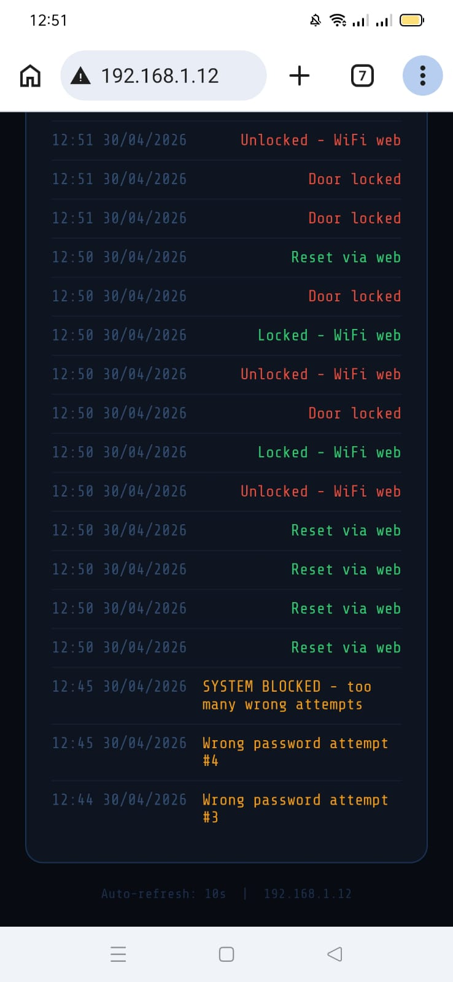
In the WiFi Web part of your project, the ESP32 acts as a mini web server that allows users to control and monitor the smart door lock remotely through a web browser.
BLUETOOTH APP:
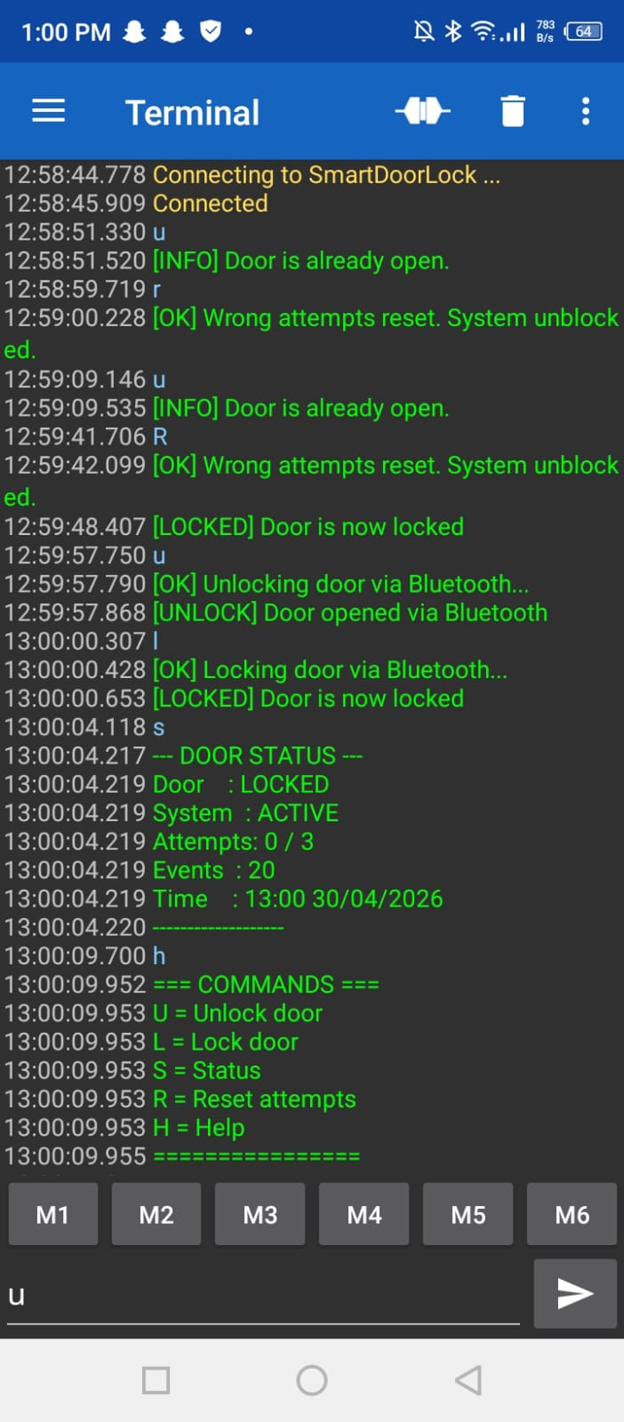
Bluetooth app (Serial Bluetooth Terminal) is used to control the smart lock wirelessly without internet. It allows unlocking, locking, checking system status, and resetting failed attempts using simple commands like U, L, S, and R. It also sends alerts and messages from the ESP32 in real time.
Overall Circuit:
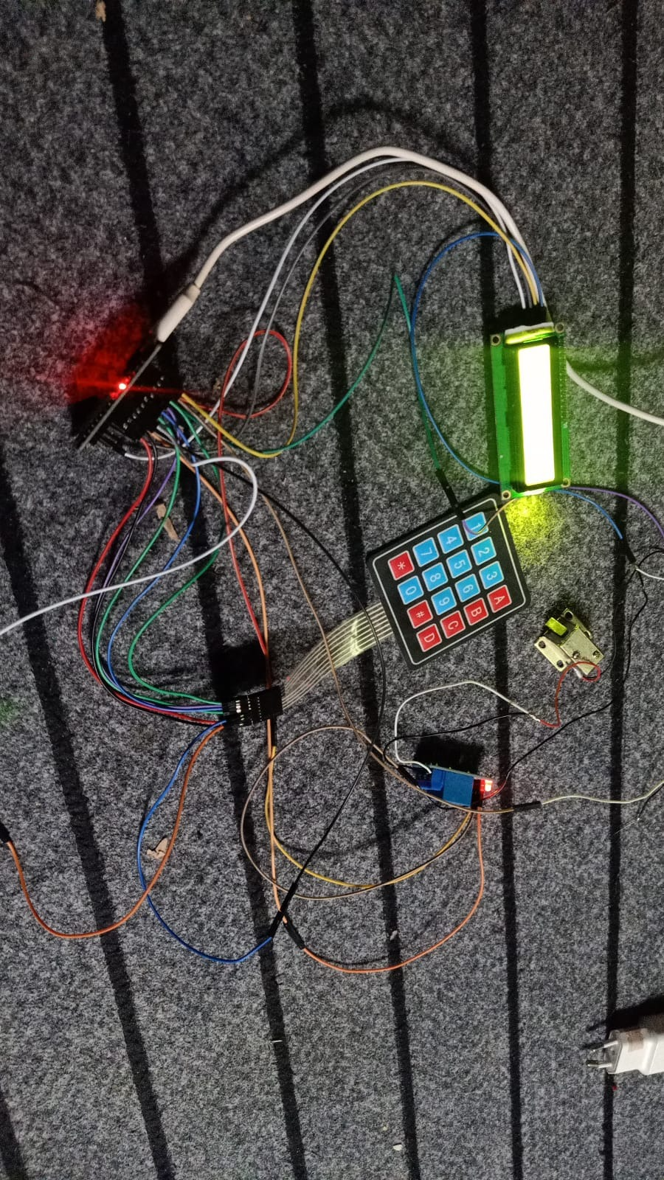

10. Conclusion:
The IoT-Based Smart Security Node was successfully designed, built, and programmed. The hardware and software integrations met all performance goals, including localized inputs, short-range serial communication, and remote web control. The safety and logging mechanisms worked reliably under simulated unauthorized access conditions. This project highlights how low-cost embedded hardware can be used to construct robust, enterprise-grade access control networks.

